Test Understanding and Technical Document
Project Name - Robot Framework with Browser Library
Tools used – Visual Studio Code , Git and Git Hub
Prerequisite:
1.Python needs to be installed
2.Install Node.js
3.Environment variable set up
4.Install Visual Studio code IDE
5.Validate PIP install robotframework-browser
6.Run command frbrowser init
7.Git and GitHUB installation
8.Install Excel Library

Sample Robot test script in VS code,
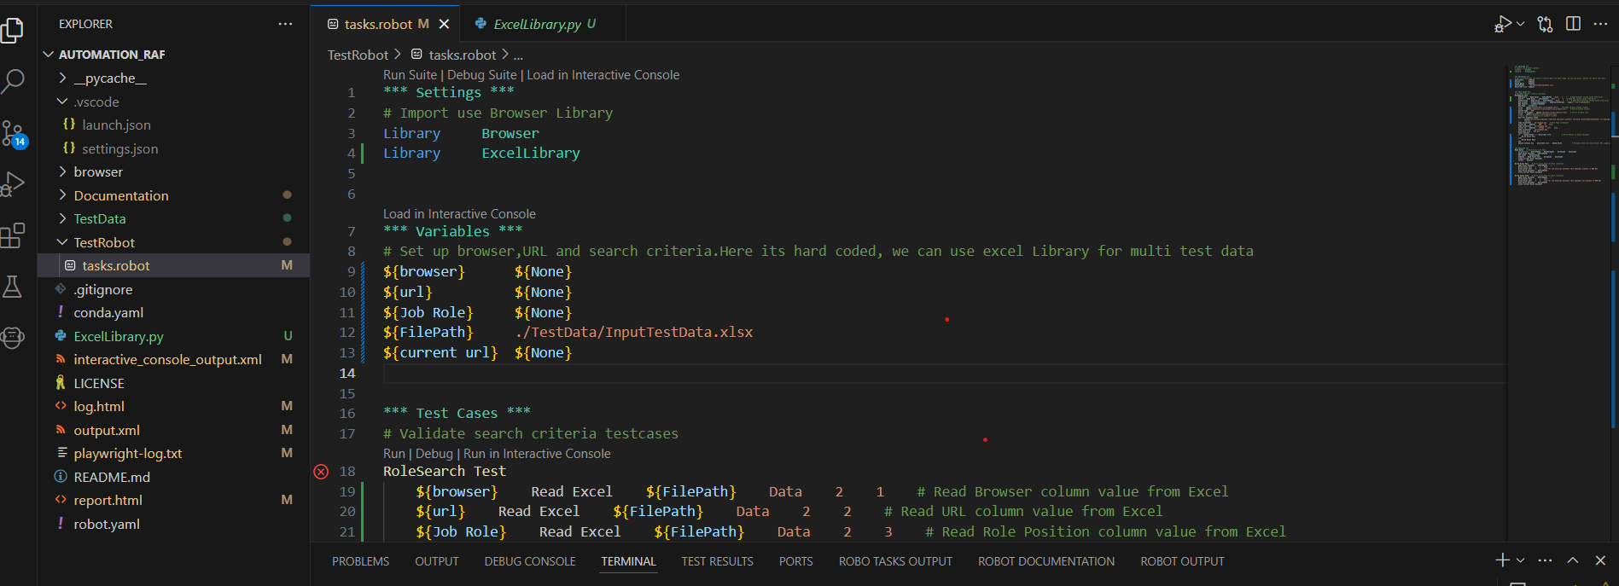
Test script details:
Currently test data is provided by Input excel data.
Output Result also stored in same excel data Result column(PASS/FAIL) and comments section
Test Result
Link for Job Position ‘Software Test Engineer’ not present in WEB URL. Please find below result references,

Excel Result update,

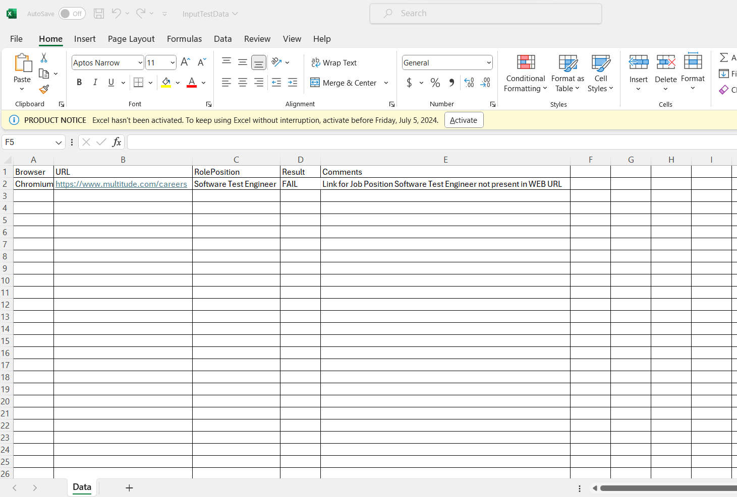
Log Report,
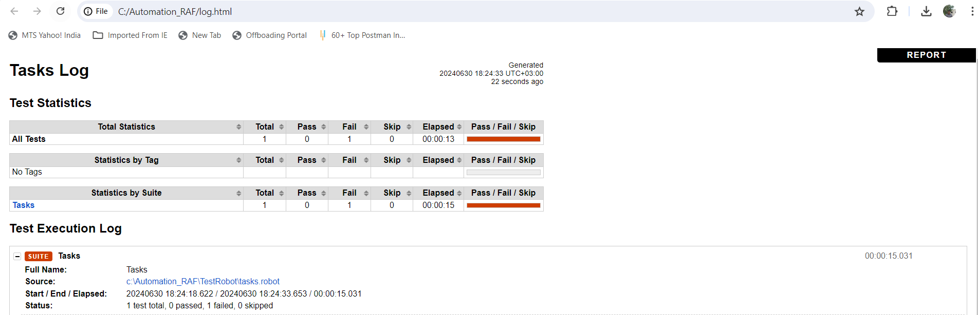

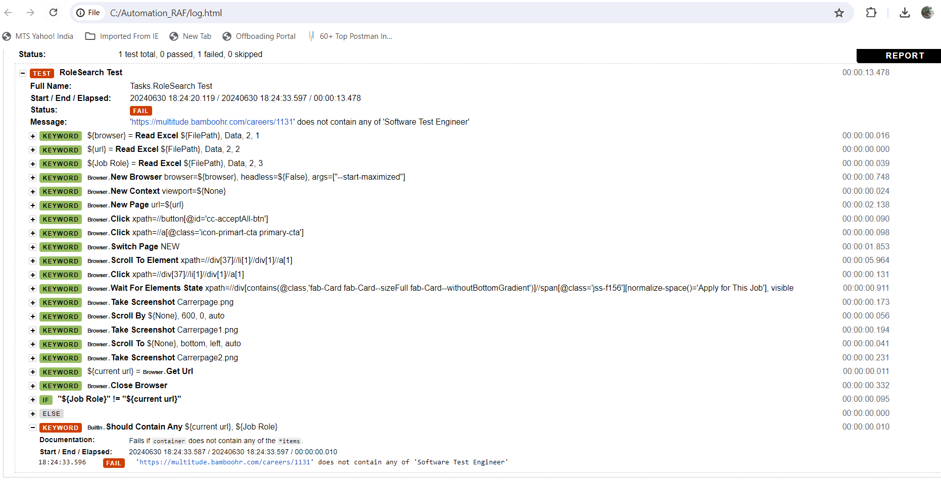

Attachments:

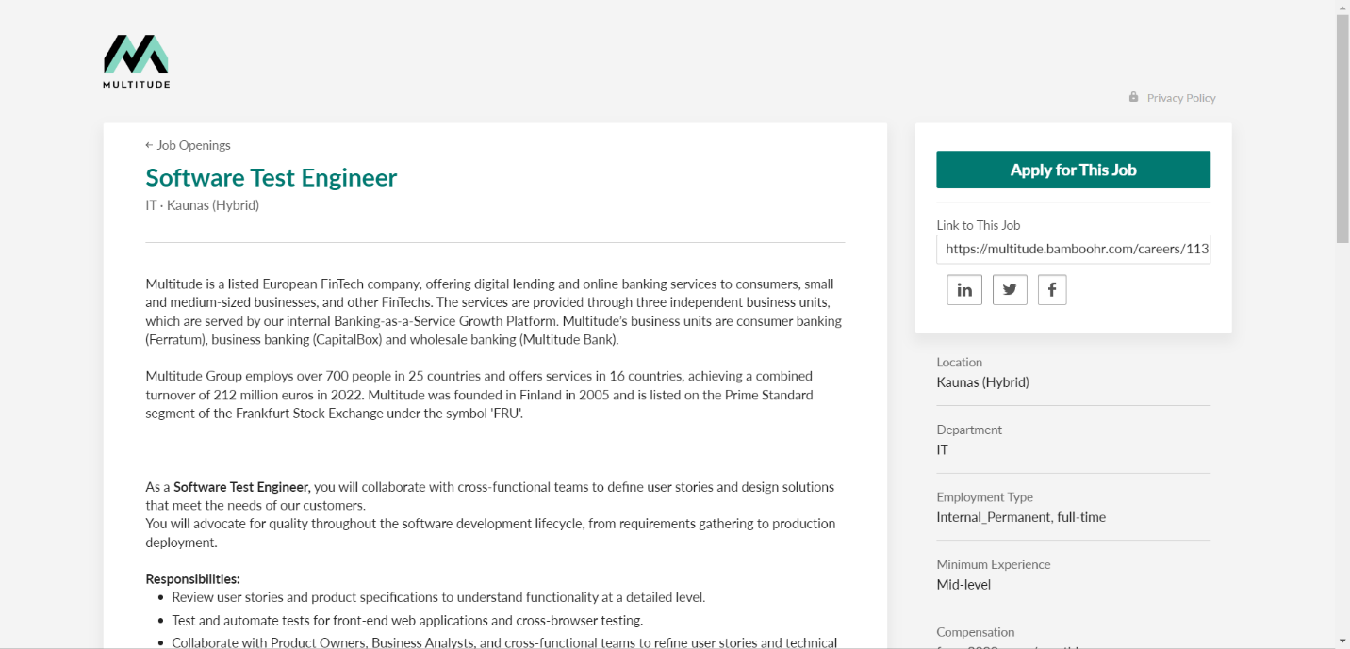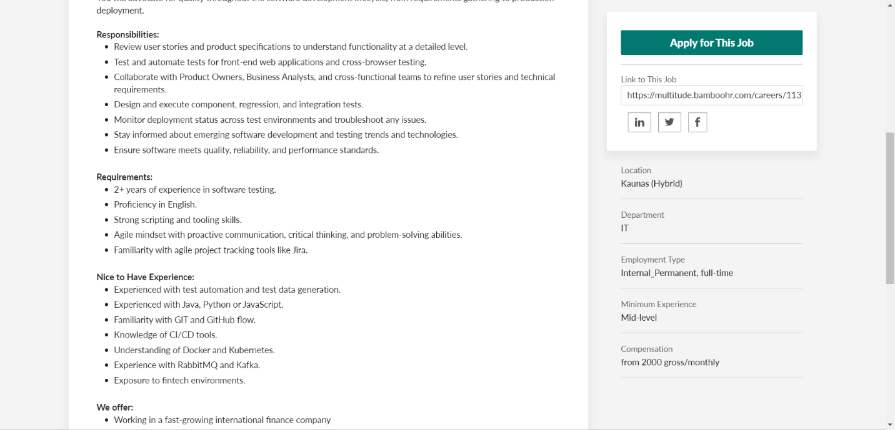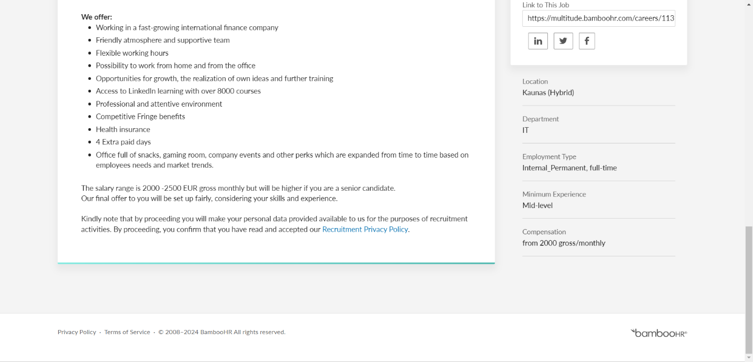

GitHub Repository Link:
https://github.com/ArunagiriSakthivel/RoleSearchRobot

